 | YEAR 12 MATHEMATICS SPECIALIST  SEMESTER ONE 2017  QUESTIONS OF REVIEW 3:  Vectors in 3 dimensions

Name: _______________________

Thursday 11th May Time: 40 minutes Mark /30

Calculator allowed.

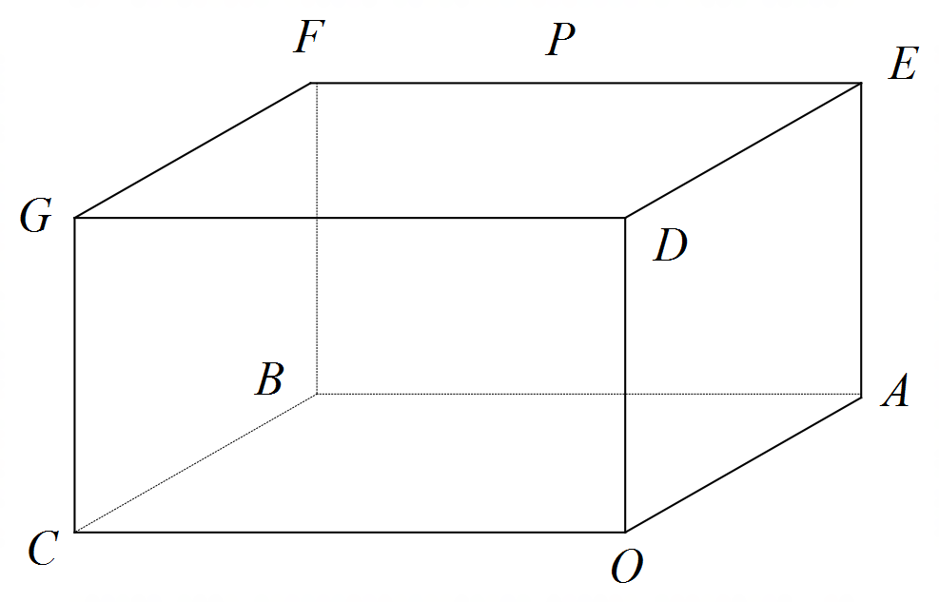

[6 marks – 1, 1, 2 and 2]
The right rectangular prism shown has vertices , , and .
Use appropriate vector methods to represent:

the position of point G

the position of point P, the mid-point of EF

an equation for the line through points C and P

the angle the line CP makes with the base OABC

[5 marks – 2 and 3]

Use and the vectors and to calculate

the area of ΔOAB

[8 marks – 1, 3, 2, 1 and 1]

Express the vector equation in Cartesian form

Calculate the point(s) of intersection of and

Describe, by a suitable vector or algebraic equation, the locus of points that are equidistant from the points of intersection found in (b)

Show that is a part of a diameter of

Calculate the distance between any pair of parallel planes tangential to opposite sides of

[7 marks – 2, 2 and 3]

The vector is perpendicular to the plane , which is itself parallel to both and .

Use scalar (dot) product calculations to set up equations sufficient to evaluate a and b

Use a vector (cross) product calculation to set up an equation to evaluate a and b

Solve for a and b and hence develop a Cartesian equation for , which passes through

[4 marks]

The position vectors of three non-collinear points A, B and C, with respect to an origin O, are , and respectively.

O does not lie in the plane ABC.
The point Q with position vector does lie in the plane ABC.

Show that

Formulae:

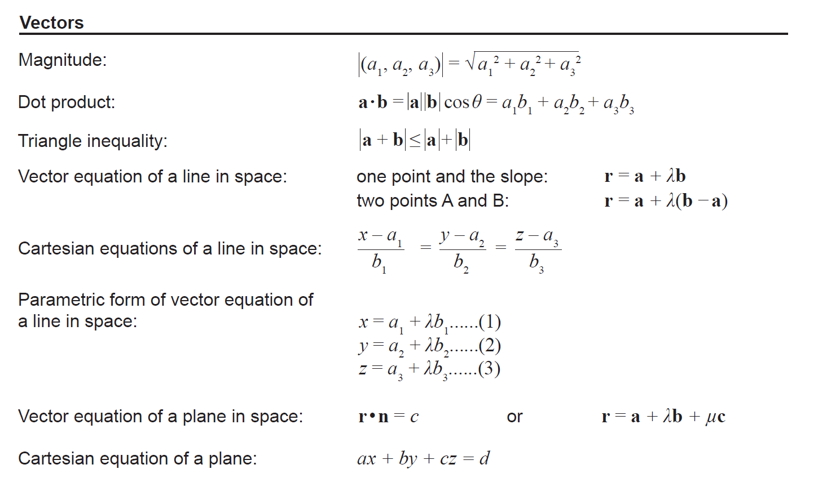

Vector cross product and
The sphere defined by has a centre with position vector and radius k

